Lab DPL

Click on logs and fetch logs

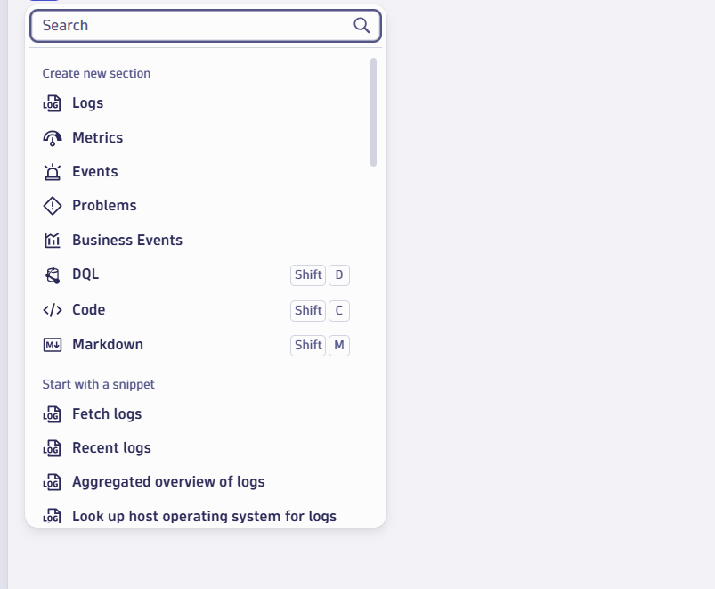

Fetch logs for 24 hours and make limit 10000

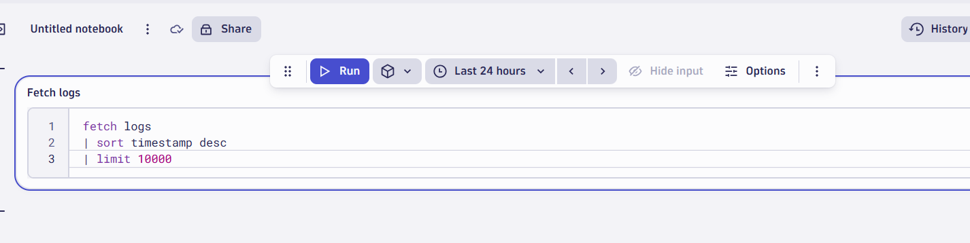

Click on run and change limit

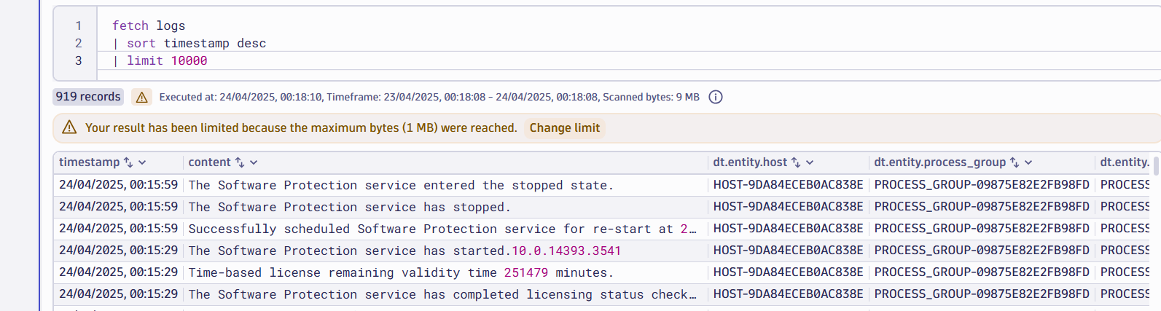

Click on contents and extract fields

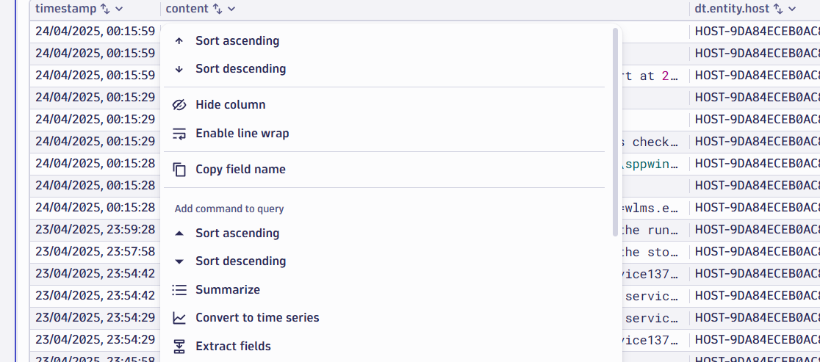

Click on saved pattern IIS default

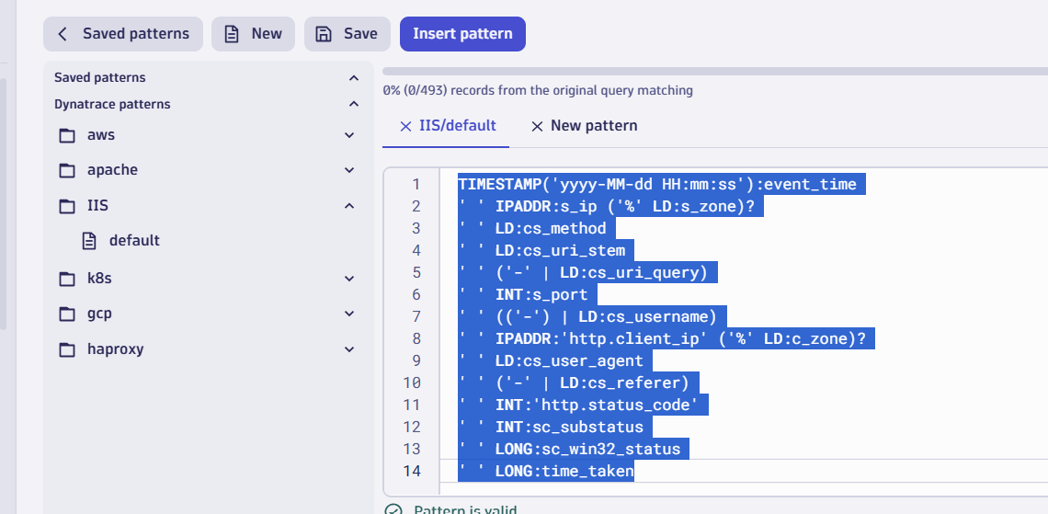

Click on insert pattern and run